Fiche réprésentation

# Mon premier ordinateur

Qu’est-ce qu’un ordinateur ?

Dessine un ordinateur :

Fiche ordinateur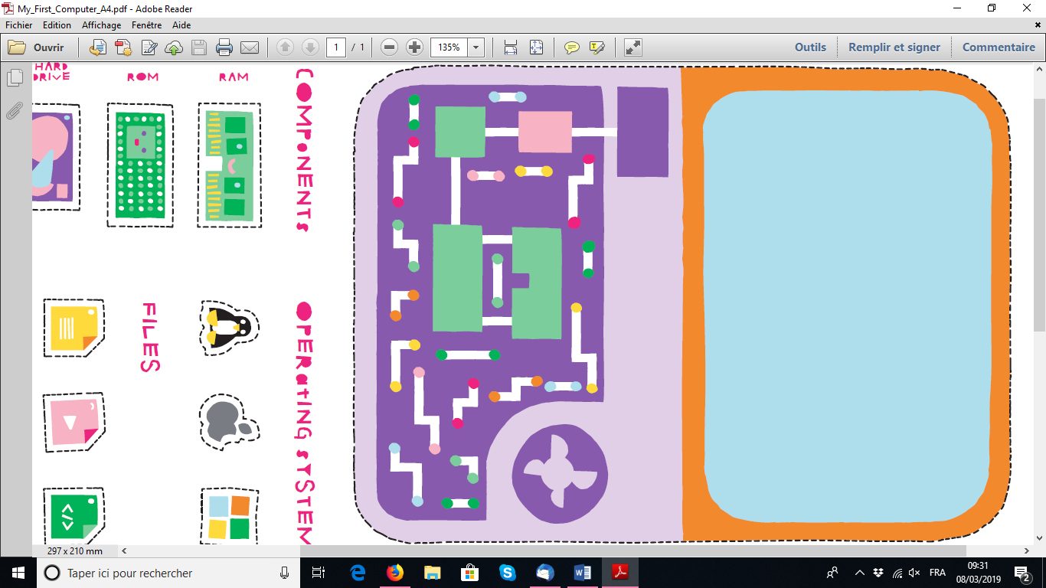



Fiche labyrinthe

Je programme mon robot :

Pour t’aider à réalise les programmes du robot, voici une reproduction miniature du labyrinthe du robot.

|  |  |  |  |  |  |  |
| --- | --- | --- | --- | --- | --- | --- |
|  |  |  |  |  |  |  |
|  |  |  |  |  |  |  |
|  |  |  |  |  |  |  |
|  |  |  |  |  |  |  |
|  |  |  |  |  |  |  |
|  |  |  |  |  |  |  |
|  |  |  |  |  |  |  |

Fiche instructions

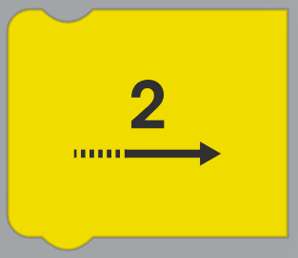Voici une reproduction de toutes les instructions du robot à ta disposition.

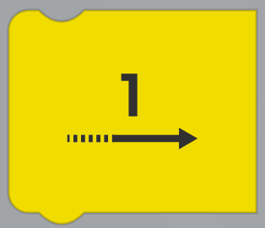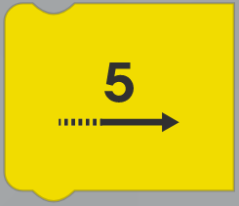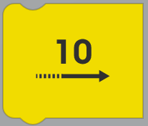

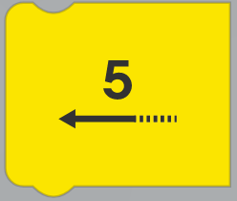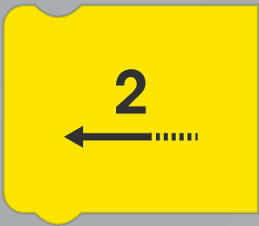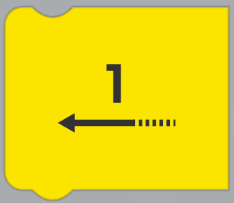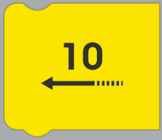

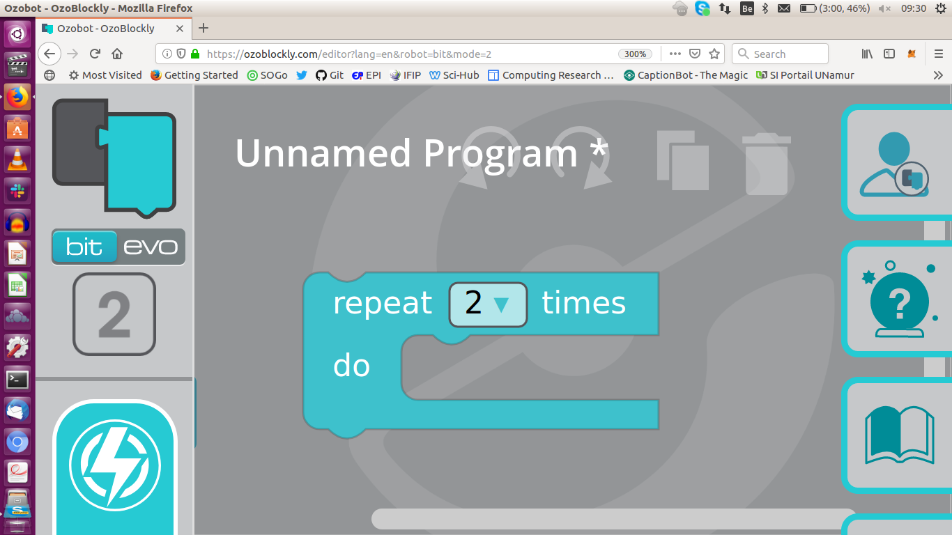

Fiche exercices

Ecris les programmes que ton robot doit exécuter pour arriver à la maison jaune. La fleche rouge vous indique dans quel sens le robot avancera si vous lui donnez l’instruction d’avancer.

|  |  |  |  |  |  |  |  |  |  |  |  |  |  |  |  |  |  |  |  |  |  |  |  |  |  |  |  |  |  |  |  |  |  |  |  |  |  |  |  |  |  |  |  |  |  |  |  |  |  |  |  |  |  |  |  |  |  |  |  |  |  |  |  |  |  |  |  |  |  |  |  |  |  |  |  |  |  |  |  |  |  |  |  |  |  |  |  |  |  |  |  |  |  |  |  |  |  |  |  |
| --- | --- | --- | --- | --- | --- | --- | --- | --- | --- | --- | --- | --- | --- | --- | --- | --- | --- | --- | --- | --- | --- | --- | --- | --- | --- | --- | --- | --- | --- | --- | --- | --- | --- | --- | --- | --- | --- | --- | --- | --- | --- | --- | --- | --- | --- | --- | --- | --- | --- | --- | --- | --- | --- | --- | --- | --- | --- | --- | --- | --- | --- | --- | --- | --- | --- | --- | --- | --- | --- | --- | --- | --- | --- | --- | --- | --- | --- | --- | --- | --- | --- | --- | --- | --- | --- | --- | --- | --- | --- | --- | --- | --- | --- | --- | --- | --- | --- | --- | --- |
| 1. Premier défi  |  |  |  |  |  |  |  | | --- | --- | --- | --- | --- | --- | --- | |  |  |  |  |  |  |  | |  |  |  |  |  |  |  | |  |  |  |  |  |  |  | |  |  |  |  |  |  |  | |  |  |  |  |  |  |  | |  |  |  |  |  |  |  | |  |  |  |  |  |  |  | | 1. 2ème parcours  |  |  |  |  |  |  |  | | --- | --- | --- | --- | --- | --- | --- | |  |  |  |  |  |  |  | |  |  |  |  |  |  |  | |  |  |  |  |  |  |  | |  |  |  |  |  |  |  | |  |  |  |  |  |  |  | |  |  |  |  |  |  |  | |  |  |  |  |  |  |  | |
| 1. 3ème parcours  |  |  |  |  |  |  |  | | --- | --- | --- | --- | --- | --- | --- | |  |  |  |  |  |  |  | |  |  |  |  |  |  |  | |  |  |  |  |  |  |  | |  |  |  |  |  |  |  | |  |  |  |  |  |  |  | |  |  |  |  |  |  |  | |  |  |  |  |  |  |  | | 1. 4ème parcours  |  |  |  |  |  |  |  | | --- | --- | --- | --- | --- | --- | --- | |  |  |  |  |  |  |  | |  |  |  |  |  |  |  | |  |  |  |  |  |  |  | |  |  |  |  |  |  |  | |  |  |  |  |  |  |  | |  |  |  |  |  |  |  | |  |  |  |  |  |  |  | |

Fiche Evaluation

|  |  |  |  |  |  |  |  |  |  |
| --- | --- | --- | --- | --- | --- | --- | --- | --- | --- |
|  |  |  |  |  |  |  |  |  |  |
|  |  |  |  |  |  |  |  |  |  |
|  |  |  |  |  |  |  |  |  |  |
|  |  |  |  |  |  |  |  |  |  |
|  |  |  |  |  |  |  |  |  |  |
|  |  |  |  |  |  |  |  |  |  |
|  |  |  |  |  |  |  |  |  |  |

Le programme a des erreurs. Barre les flèches qui sont fausses puis réécris les bonnes flèches, et ajoute les flèches qui manquent pour que le bee-bot sorte du labyrinthe.

|  |  |  |  |  |  |  |  |  |  |
| --- | --- | --- | --- | --- | --- | --- | --- | --- | --- |
|  |  |  |  |  |  |  |  |  |  |
|  |  |  |  |  |  |  |  |  |  |
|  |  |  |  |  |  |  |  |  |  |
|  |  |  |  |  |  |  |  |  |  |
|  |  |  |  |  |  |  |  |  |  |

Le programme est trop long. Réécris le en utilisant le moins de flêches possible.

|  |  |  |  |  |  |  |  |  |  |
| --- | --- | --- | --- | --- | --- | --- | --- | --- | --- |
|  |  |  |  |  |  |  |  |  |  |
|  |  |  |  |  |  |  |  |  |  |
|  |  |  |  |  |  |  |  |  |  |